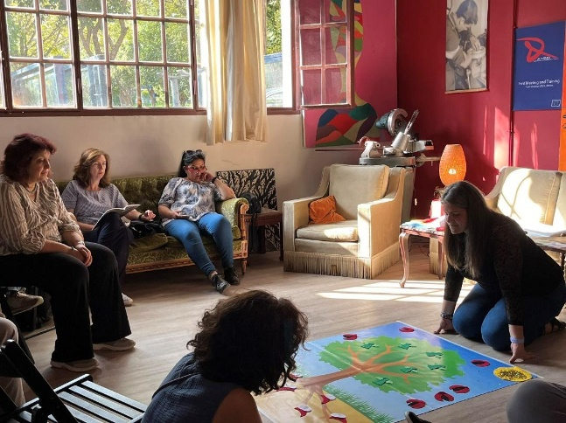

REPORT ON WORKSHOPS ON METHODS
NAME OF THE METHOD | SEDIN
TRAINER | Silvia Viaene
WHEN-WHERE | Leuven-31/5/2024
MICROTEACHING TOPIC | ‘The story of the Phothosynthesis’
EDUCATION LAVEL | Primary school
PREPARATION BY THE TRAINER | -I become aware of the importance of every word in this beautiful story. I am so positively surprised by the playful and attractive way in which scientific knowledge is taught.  -It was very useful to see the photo (Sarah) of this activity in Athens and even more so the chronological drawings (chart 1-9) associated with the story given in the Montessori manual! In this way, it was clear how to use the resources in the story.
SUGGESTIONS ON THE RESOURCES | -It is very nice to have already the materials in the resources! Maybe, some minor suggestions around the resources :  - Could it be an idea to have the resources also in word-version? For example, for using the tree mat, it was difficult to make the size bigger because of the pdf-version. Of course, the trainer can also make his own design, but if you want to offer it to the trainer, it would be maybe also useful to have the word-version also.  - This is just a very small note, but the sun could possibly also be present in one way or another (on the picture of tree mat, or in person, like a pupil or …). Of course in the picture it is clear that it is daytime, but to emphasize even stronger the importance of the sun.  - Another very small thing I noticed in the resources : there are 18 oxygens needed in stead of 12.  To make the figures of the carbon flyers and the water mice, I messed around with stickers, also due to lack of time (😉), but in retrospect I think the use of velcro is the most convenient for this to use them (most durable).  - In Athens after the story, we were shown an atom model of glucose, which was very nice to see because of the three-dimensional view and the link with the reality. We can see the similarity with the molecules (2-dimensional) made in the story. I would suggest showing the three-dimensional model also in the training after telling the story because it remains important for the learners to repeatedly make the link with real reality (in this case 'invisible' reality) in function of meaningful learning.  Because not every trainer/teacher has such a model, I think it would be also a good idea to add the photo of the atomic model (glucose) in the resources of the training? It makes the story extra credible (meaningful learning) and it also refers to the importance of the use of the specific colors such as red, black and white and so to respect the importance of the colors in the story, even if the trainer doesn’t want to show already the atom model to the learners (because the trainer doesn’t want to teach chemistry already for the young learners).
WHAT WE DID -APPLICATION | Steps:  - Very short description of methodology SEDIN : The principles of the method ‘CLEAR’ are in the Montessori-approach used to stimulate the wondering and curiosity of children. This is where both methods come together : the idea that curiosity, wondering is the key for learning. This methodology is used for the age of 6-12 years old children).  - Learning subject = photosynthesis  - Telling the story about photosynthesis while using materials  - Reflection of trainer on the experience of just now and also on the practical side of the preparation and implementation (materials, learning environment,..).  - Group reflection on telling the story of photosynthesis.  - New ideas were offered by the group and the trainer to make creative learning about photosynthesis even stronger.
FEEDEBACK FROM TRAINEES | -Their knowledge about photosynthesis was improved.  -The first question was about the age of the learners. In the synopsis is mentioned the story is for children of the age of 6-12 years old. There was some doubt about a more specific age…? (We have the story and on the other hand a more difficult content like photosynthesis.)  -The trainees saw a lot of opportunities to link this story to many different topics, for example : climate change, felling trees, falling of the leaves,….The story can be an impression for many interesting topics.  -At the end of the story, a trainee asked for the taste of glucose…. and compared it to the taste of a sweet food. It was a beautiful question! This questions connects us, as human beings, with the trees/plants! Just like plants/trees, people also eat sugar to get energy (cell respiration). However, people do not produce their own sugar like plants do. Unfortunately, I haven't gone into this enough during the training!  -Someone suggested to start for example with the taste of an apple (sweet) before telling the story. The apple is something from the learner's immediate world and is therefore a good starting point to direct attention to this story. So the apple connects the story to real reality and makes the story even more meaningful.  -Someone suggested to start with the different parts of the tree before telling the story.  -Someone find the chemical reaction the most interesting, because of the possibility to have a more interactive dialogue.  -Someone suggested using more drama elements during the storytelling. For example, the learners can imitate the rain (strumming fingers on thighs) while talking about the water mice,……  -We suggested to further stimulate the internalization of this knowledge, by playing the photosynthesis after this storytelling, being in a role of an atom or an elf and presenting the tree/the sun/the earth by using materials (décor). For example, the red oxygens can wear a red T-shirt,….. The chemical connections between the atoms (molecules) can be demonstrated by giving each other a hand(s) are by cuddling ,…….etc.  -Trainees make the connection between this story and previous knowledge. For example, one trainee shared her wonder about fungi that live underground and so the trainee inspired the others with her/his experiences or knowledge.
REFLECTION BY THE TRAINER AFTER THE WORKSHOP | -To increase the children's involvement, it is also very important to stimulate sufficient interactive dialogue during storytelling in addition to the use of attractive materials. Also I could integrate more drama-elements to increase the active involvement of children (e.g. asking the children to imitate the movements of vigorously stirring.). Especially during the separation of the elements, which does take some time from the trainer to separate all the figures.  -In the training beautiful activities are chosen around different topics in the different phases. I understand correctly that the teacher is supposed to provide some start-up activities or follow-up activities, depending on the particular context in the classroom? (For example, the activity ‘Let’s make a cell’ is an activity that requires some prior knowledge of the cell learned in previous activities.)  -It is also possible to let the trainees retell the story (in groups) by using the materials.  -You can also integrate maths (f.e. 6 carbonflyers with two wings (=red oxygens), how many wings?,…).  -There is also lot of vocabulary in the story (specific to the tree : roots, leaves,…). They can learn first the different words and after that, they can hear the story in which the words are used in a context.  -the non-verbal communication makes the learning process less dependent of languages. But by telling the story while acting, the learners are also stimulated to learn language.
GENERAL CONCLUSIONS | It is a beautiful method to use! The story triggers the curiosity and makes learning more fun!
APPENDIX | Materials:  1) Resources JOINT CURRICULUM ACADIMIA :  -mat of tree for telling the story  -template for cutting out felt pieces to tell the story ( elves, hydrogens, carbons, oxygens)  2) Resources in the Montessori manual :  The chronological drawings (chart 1-9) associated with the story  3) Resources internal training rapport Athens :  Foto of Sarah telling the story during the training in Athens
Any photos / videos? | Where they are, if any : ACADIMIA WP 1 Management /TPM Leuven