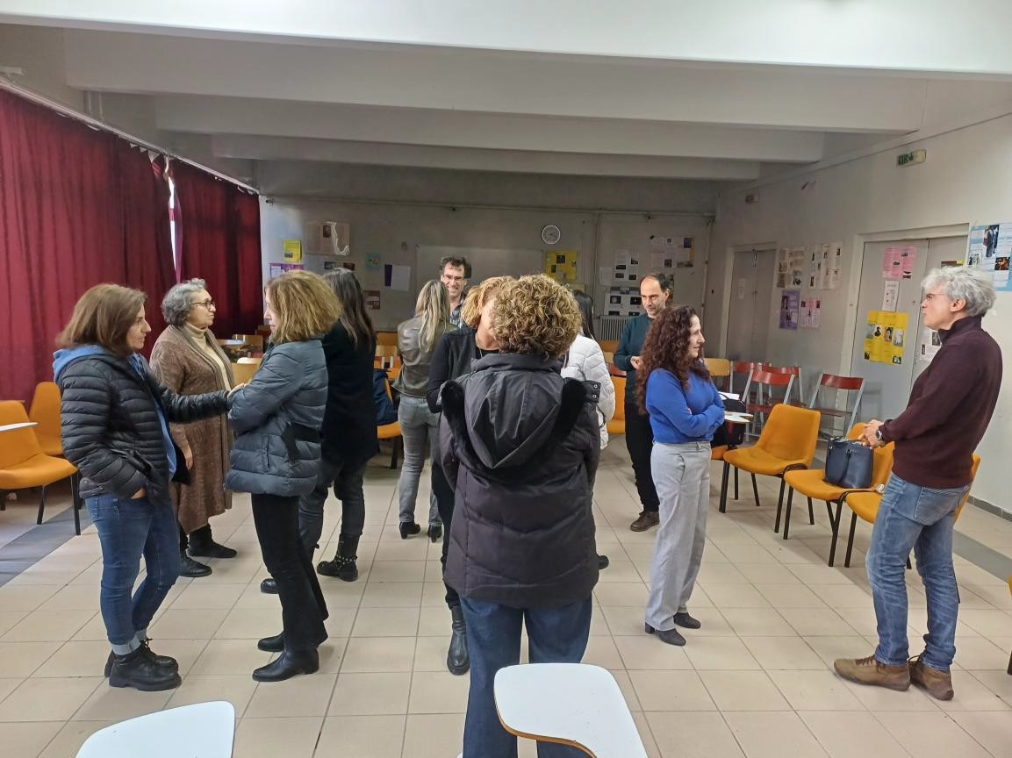
ACAδIMIA – EAR

The second training session within the framework of the European program ACAδIMIA – «ACADIMIA-European Teachers’ Academy for Creative and Inclusive Learning» - was conducted using the creative learning method EAR, which is based on dialectical and theatrical techniques, for the teachers of the 2nd Senior School of Gerakas on the 19th of December 2024.

The session began with homogeneous circles, focusing on social and educational topics that the teachers discussed in pairs. This was followed by a brief presentation of the EAR educational methodology.

In the final part of the session, participants formed three groups and worked on three techniques:

- Fishbowl
- Consciousness Corridor
- Forum Theatre

Before applying these techniques, the teachers discussed the definitions of the topics they explored. At the end of the session, they reflected on how they could implement these methods in their teaching. They expressed that they particularly enjoyed the seminar.

Responsible of Workshop

Pertsinidou Corinna
Coordinator of Educational Programs and Networks of the Directorate of Secondary Education of Eastern Attica
Trainer of ACADIMIA - «ACADIMIA-European Teachers’ Academy for Creative and
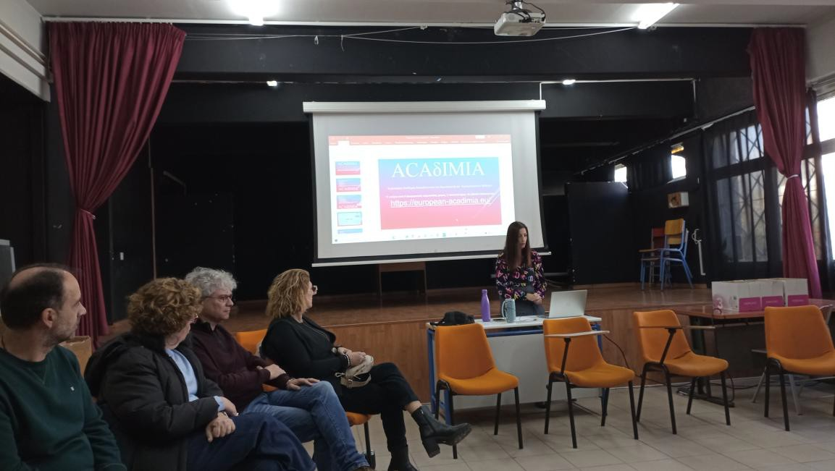
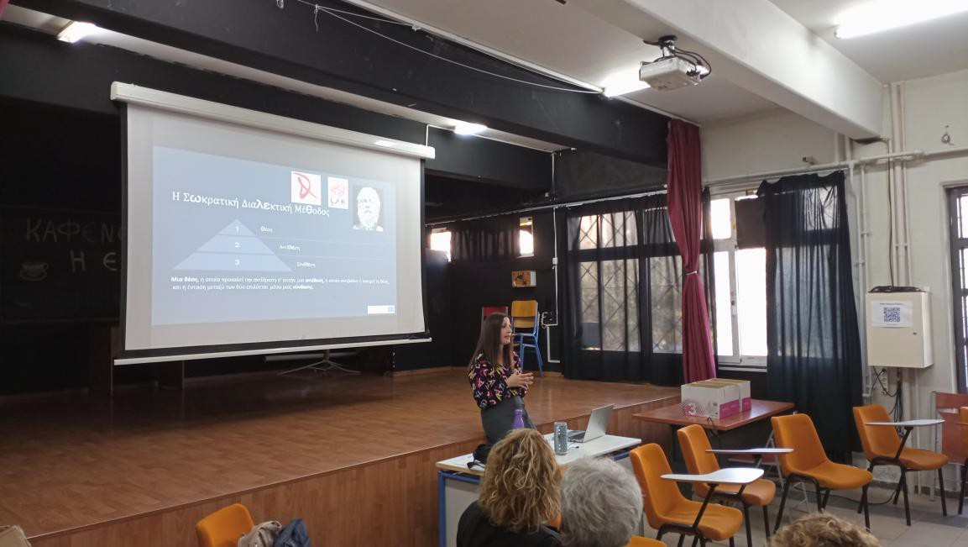
Inclusive Learning»

