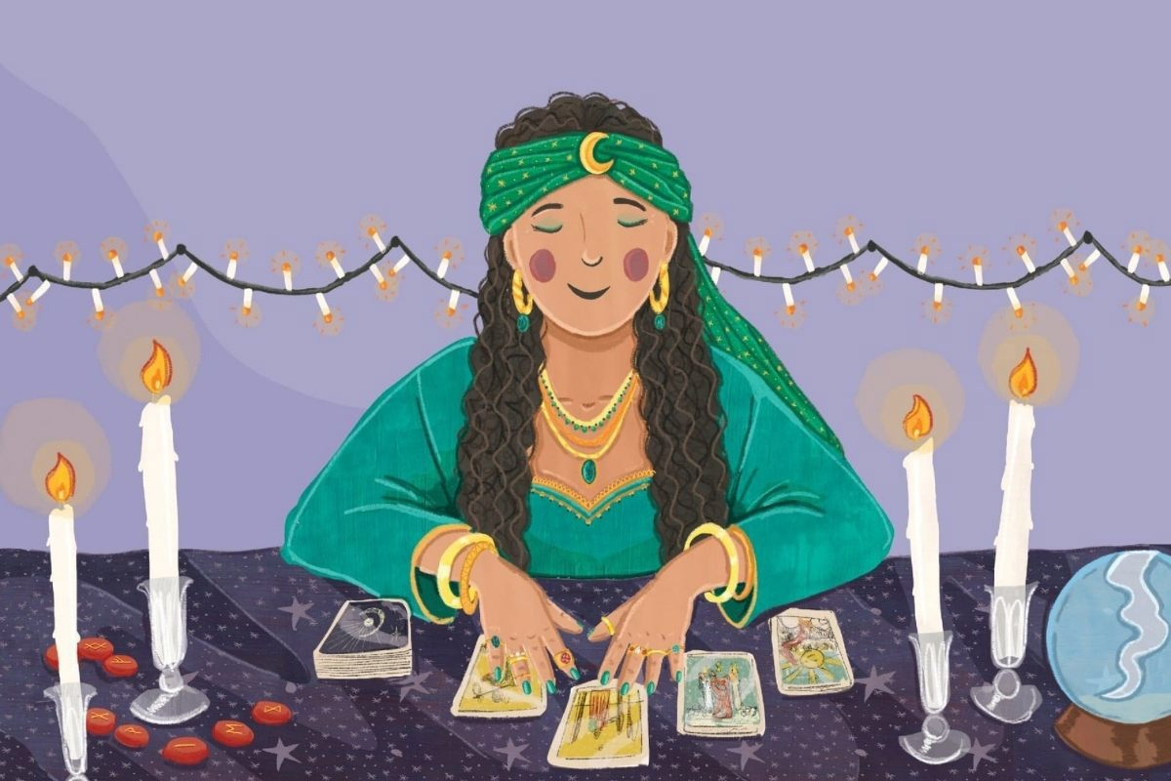

REPORT ON A WORKSHOP ON THE CREATIVE LEARNING METHODΟOGY
Language-Practicing Future tense
Ifigenia Georgiadou

NAME OF THE METHOD | CREATIVE LEARNING
TRAINER | Ifigenia Georgiadou
WHEN-WHERE | Leuven-31/5/2024
MICROTEACHING TOPIC | Language-Practicing Future tense
EDUCATION LEVEL | 6-12 Grade -Primary and Secondary, Adults
PREPARATION BY THE TRAINER | I was inspired by the ideas on Language teaching from the project website https://creativitylearning.eu/language/  And decided to prepare and activity that includes some storytelling and also playing a role in the class.  I collected ideas and I also liked the Storytelling examples on the website.  I created the materials based on an activity where all learners should practice all four language skills: writing, listening, reading, speaking.
SUGGESTIONS ON THE RESOURCES | Perhaps we need all ideas described on the same template. Good to have materials in different languages, the website helps on that.
WHAT WE DID -APPLICATION | Steps:  - Students get cards with certain 4-6 words. They have to write a short text entitled "the dream I had last night", using these words.  - Then they are divided into pairs. Each student, who will be the Fortune Teller, (and she/he has a label with start that writes FORTUNE TELLER) gets a symbol card that explains the words of their classmate, with whom they will work. Based on the "symbol cards" each tries to explain the other's dream. Tell them to add whatever they think and play the role of a fortune teller!  - At the end every person creates a still image of her/his dream.  - If they want they can create a collective still image all together.  - Or they can add sound and motion to it.
FEEDEBACK FROM TRAINEES | - It was a well structured activity, and went really well and on time, apart from the still image at the end, we did not have time for that  - Sometimes we should remember to use future tense. What is it is not natural?  - A good idea would be to have maybe one of the students as a “secretary” who can write down how many times the Future tense was used correctly, some scores you will set, how well structured was their narration or their text etc  - We had fun with this game  - It creates feelings, thus it involves 100% the students
REFLECTION BY THE TRAINER AFTER THE WORKSHOP | - We have to think what to do if some of the trainees finish their writing earlier. Solution: we match them together, changing the order for pairs  - We can use a paper that has pictures on it so that they can be inspired more  - We can give the instruction that the Fortune Teller can ask questions in order to bring the narration near to the Symbols Card  - We should remind them to use Future tense  - How could we show who the Fortune Teller is, apart from the label? There must be other ways  - It takes time, but it practices a lot of skills. But beware of the difficult information that the symbol cards may include and of what can be said: some students, for some reason, give more importance to the words of the game than they should and get upset sometimes.  - choose the easy words for your weak students. Make pairs that get along well with each other. A climate of trust needs to be developed in the team.  - use a real " Dream Book " if you want to make more cards.
GENERAL CONCLUSIONS | We need to have any curriculum topic and try some of the techniques the CREATIVE LEARNING method proposes. They are all
APPENDIX | Materials:  attached below the plan and the materials (card of two types)

"Dream book or Fortune teller"
Level: Intermediate, Advanced
Cognitive Area: revision of known vocabulary
Skills practiced: speaking, listening, writing, reading, drama skills
Time: 15 - 40 minutes, depending on the number of students
Materials: cards-two kinds
Method of work: first individually, then in pairs

Description: Students get cards with certain 4-6 words. They have to write a short text entitled "the dream I had last night", using these words. Then they are divided into pairs. Each student, who will be the Fortune Teller, gets a symbol card that explains the words of their classmate, with whom they will work. Based on the "symbol cards" each tries to explain the other's dream. Tell them to add whatever they think and play the role of a fortune teller! At the end every person creates a frozen picture of her/his dream. If they want they can create a collective frozen picture all together. Or they can add sound and motion to it.

Notes: 1) very fun game. It takes time, but it practices a lot of skills. But beware of the difficult information that the symbol cards may include and of what can be said: some students, for some reason, give more importance to the words of the game than they should and get upset sometimes.
2) choose the easy words for your weak students. Make pairs that get along well with each other. A climate of trust needs to be developed in the team.
3) use a real " Dream Book " if you want to make more cards.

"FORTUNE TELLER" cards
Words from my dream 1  Snow  Fish  Bread | Words from my dream 2  Cat  Feast  Weather
Words from my dream 3  Warehouse  Wind  Barrel | Words from my dream 4  Frame  Priest  Shoes
Words from my dream 5  Sick  Balcony  Mirror | Words from my dream 6  Forest  Furniture  Summer
Words from my dream 7  Piano  Church  Miracle | Words from my dream 8  Rain  Marriage  Day
Words from my dream 9  Easter  Wash  Wine | Words from my dream 10  Legs  Glass  Stage
Words from my dream 11  Oregano  Living room  Scorpio | Words from my dream 12  Table  mountain  fire

FORTUNE TELLER SYMBOL CARD 1
Snow: If you walk on snow you will have great joy, but only for a short time. You'll have a problem later.
Fish: If you fish or buy or eat fish, you will have joy and money.But if these fishes are small, you may have problems.
Bread: If it is white bread, you will have good news. If it is black you will have some problems for a short period of time.
-------------------------------------------------- -------------------------------------------------- ---
FORTUNE TELLER SYMBOL CARD 2
Cat: If you see a cat, someone is jealous of you. If you pet a cat, your love the lies. If your cat meows, it's bad for you.
Feast: If you see that you are at a feast/celebration, you will have problems for a while, but later everything will be fine. If you see that it is your holiday but it is not, you will have fun and have a good time.
Weather: If the weather is good, your business will go well, if it is cloudy you will have difficult problems. If it rains, you will have problems again.
-------------------------------------------------- -------------------------------------------------- ---
FORTUNE TELLER SYMBOL CARD 3
Warehouse: If it is full you will suddenly have a lot of money. If the warehouse is empty, then you must help your poor relatives.
Wind: If it is hot wind, then you will be sick for a while. If it is cold, you will be fine and you will have great courage in your life.
Barrel: If it is full of wine, your business will go well. If it is full of water, you will have something good in your life because you are not lazy. If you see that you are making a new barrel, you must change your character.
-------------------------------------------------- -------------------------------------------------- --
FORTUNE TELLER SYMBOL CARD 4
Frame: If you see a nice frame you will have great joy and you will see a dear friend again. If the frame is bad, you will have a problem with your friends.
Priest: If you see only one priest you will be very sick for a while. If you see many priests together in your house you will be sick for longer or you will have no money at all.
Shoes: If you see that you have nice shoes, you will have money and a good job. If you see that you have old shoes you will be very poor for a few months. If they are small for your feet you will have some difficulties.
-------------------------------------------------- --------------------------------------
FORTUNE TELLER SYMBOL CARD 5
Sick: If you are sick in a dream, you might get sick for real. You may also have financial problems. If another person is sick, that person is unhappy. If you take care of a sick person, your life will be better.
Balcony: If you are on the balcony, you will become a politician, or you will become a manager at your job. If you are under the balcony, someone is laughing at you.
Mirror: If you see your face in the mirror, it is good. If you are sick, you will be healed. But if the mirror is broken, something bad awaits you.

---------------------------------------------------------------------------------------------------------
FORTUNE TELLER SYMBOL CARD 6
Forest: If you are in a large and wild forest, you are in danger of a great disaster. If you see it on fire, disaster is near. If you cut wood in the forest, your work will give you a lot of money.
Furniture: If you see your home with new furniture, you will have joy and love in your home. If the furniture is old, you will be in a difficult position.
Summer: If it is summer and you see in your dream that it is summer, you will have good news from a friend who is far away. If it is winter and you dream that it is summer, you will have profits from your business.
-------------------------------------------------- -------------------------------------------------- --
FORTUNE TELLER SYMBOL CARD 7
Piano: If you have a piano or play the piano, you will have problems at your home. A beloved person will be in danger of going mad.
Church: If you go to church and think about God and the liturgy, everything will be well in your relationships. If you don't think about the mass and think about other things, then your business will flourish.
Miracle: If you see a miracle happening, the dream is not good. But if a saint performs the miracle then the dream is good, you will have health and beauty.
-------------------------------------------------- -------------------------------------------------- ---
FORTUNE TELLER SYMBOL CARD 8
Rain: It is not good to rain, you will have problems and you will be sick. Business will go badly. But if the rain is very heavy, then the problems will be solved.
Marriage: If you are married , your business will go well. If you are invited to a wedding with feast and music, a friend of yours will be healthy​ and wealthy.
Day: If you see a nice sunny day, your business will go well. If it is cloudy, you will have problems in love. If it was night and suddenly it became day, then your life will get better.
-------------------------------------------------- -------------------------------------------------- ---
FORTUNE TELLER SYMBOL CARD 9
Easter: If you see that it is Easter, you will learn something pleasant. If you have fun and dance on Easter, you will really have fun with friends and family.
Wash: If you wash your hands, you will hear something bad and you will try to save yourself from something. If you wash your face or head they will make a good proposal to you.
Wine: When you see wine, the dream is always good.
------------------------------------------------- -------------------------------------------------- ---
FORTUNE TELLER SYMBOL CARD 10
Legs: If your legs are tired you will go a long way. If you wear big size of shoes you will be successful in your work.
Glass: If you hold or are offered an empty glass, watch out because if you're not careful - you'll be in a big danger.
Stage: If you see a theater stage you will have a great passion. If the work is a drama, you will have distress. If it's a comedy, cheers.
-------------------------------------------------- -------------------------------------------------- ---

FORTUNE TELLER SYMBOL CARD 11
Oregano: No matter how you see oregano, the dream is bad. But if you see that you eat it, the problems will become bigger.
Living room: If you see yourself entering a nice living room, you will meet a good new friend. But if the living room has no light, your work will have a problem.
Scorpio: If you see a scorpion, you have dangerous enemies. If you are bitten by a scorpion, then one of them will harm you.
-------------------------------------------------- -------------------------------------------------- --
FORTUNE TELLER SYMBOL CARD 12
Table: If the table is empty you will have a lot of money. If you eat on this table you will be successful in your work.
Mountain: If you are climbing the mountain , watch out because many difficulties will occur. If the mountain is high, the difficulties will disappear soon.
Fire: If you see a big fire outdoors you will have great success. If the fire is in a fireplace inside a house, you will have a disaster that is going to end soon.

-------------------------------------------------- -------------------------------------------------- --

