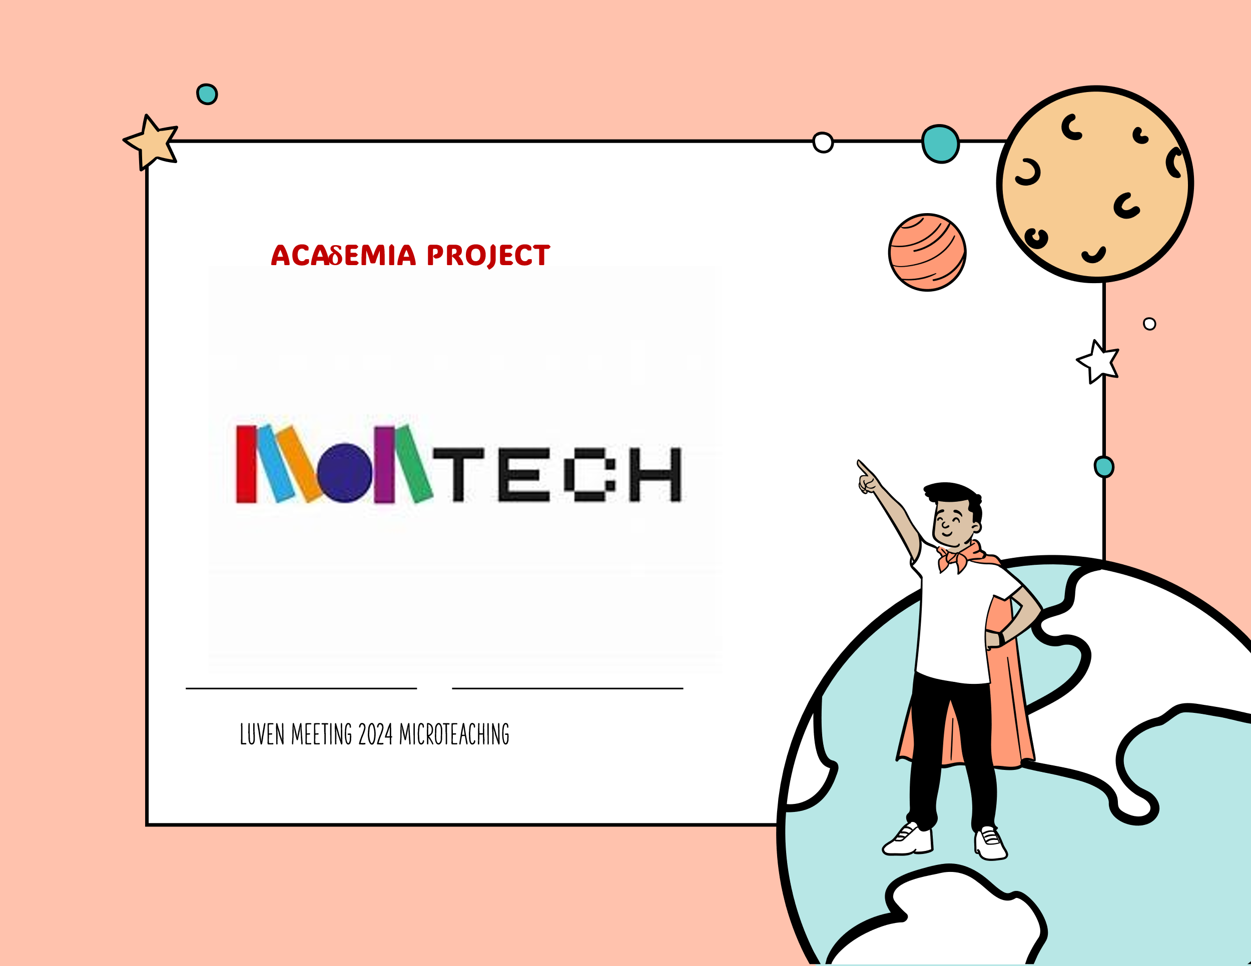

REPORT ON WORKSHOPS ON MONTECH METHODOLOGY
NAME OF THE METHOD | MONTECH
TRAINER | NIKOLAS KAMTSIS
WHEN-WHERE | Leuven-31/5/2024
MICROTEACHING TOPIC | ABOUT ROBOTS AND HOW THEY WORK AND ACT
EDUCATION LEVEL | 6-12 Grade -Primary and Secondary, Adults
PREPARATION BY THE TRAINER | I was studying the robot case study mentioned by the Girona university in the website of MONTECH method: https://montessoritech.eu/  I Prepare an activity about the function of robots. I made the layout of the classroom accordingly using the desks and the chairs.  I cut piece of color papers (red, green and blue) for the participants. These papers were the orders participants will give to the special participant who would be and pretend the robot.
SUGGESTIONS ON THE RESOURCES | none
WHAT WE DID -APPLICATION | Steps:  - I described the method with a sort power point  - During the brake I construct the layout of the space as a Labyrinth with 2 paths using the desks and the chairs. IN the classroom there were 2 paths and 2 robots.  - I put the robots (a participant) to the starting point of the paths.  - I gave the pieces of color papers to the other participants. So, we made 2 groups of 4 participants each one of them. One was the robot and the other 3 were the “orders” with the color papers. The “orders” will put on the floor the color paper: Red when they want the robot to go forward, Blue when they want to turn right, Green when they want the robot to turn left. The target was to drive the robot as fast as they can through the paths to reach the end and get a price. Who of the robot will be first and winner?
FEEDEBACK FROM TRAINEES | - It was a well structured activity, and went really well and on time.  - They had a good fun.  - They understand how a robot can move and act according the right order.
REFLECTION BY THE TRAINER AFTER THE WORKSHOP | It takes little time, to understand the meaning of the color paper as order to the robot, but after some robot’s steps they went well.
GENERAL CONCLUSIONS | It is possible to implement ways to understand how robot can work following alternative teaching methods with movement, participatory game etc.
APPENDIX | Materials:  Simple Power point presentation  Pieces of color papers.  Layout of the space.
Any photos / videos?

