Evaluation Development of Strengths (teacher) Name: ________________________ Class: __________ Date: ___________

Theme: ________________________________________________________






You felt : when you: _______________________________________

________________________________________
Happy Afraid Angry Sad Dislike Surprised

What we did: Goals of the lesson: You showed your strengths in: How did you learn:
Looking up children’s rights and examples.  Discuss children’s rights and examples.  Group children’s rights and examples.  Connect Children’s rights to own experiences  Experimenting with persuasive writing.  Write a persuasive letter or a pamphlet | - You explore children’s rights: which ones exist, how many exist, what is in them?  - You group children’s rights under the 3 Ps and know when we speak about ‘violating’ and ‘respecting’ rights.  - You can give examples of situations concerning children’s rights, potentially taken from your personal life.  - You reflect on children’s rights in different ways and can explicit how this makes you feel.  - You get acquainted with how to write a persuasive text.  - You experiment with elements of a persuasive text.  - You combine elements of a persuasive text to write a letter or pamphlet. | O  O  O  O  Where you can improve:  O  O  O | 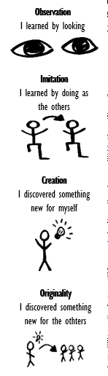

What did I learn? _________________________________________________________________________________________________

Your challenges: __________________________________________________________________________________________________

Where can you improve: ____________________________________________________________________________________________

What do I need? __________________________________________________________________________________________________

What is the next step? ______________________________________________________________________________________________

