Evaluation Development of Strengths (student) Name: ________________________ Class: __________ Date: ___________

Theme: ________________________________________________________






I felt : when I: ________________________________________

________________________________________
Happy Afraid Angry Sad Dislike Surprised

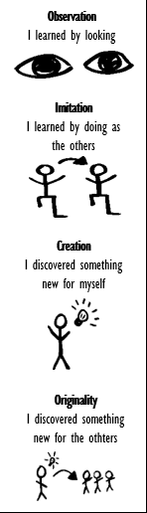
What we did: Goals of the lesson: I showed my strengths in: How did I learn?
Looking up children’s rights and examples.  Discuss children’s rights and examples.  Group children’s rights and examples.  Connect Children’s rights to own experiences  Experimenting with persuasive writing.  Write a persuasive letter or a pamphlet | - You explore children’s rights: which ones exist, how many exist, what is in them?  - You group children’s rights under the 3 Ps and know when we speak about ‘violating’ and ‘respecting’ rights.  - You can give examples of situations concerning children’s rights, potentially taken from your personal life.  - You reflect on children’s rights in different ways and can explicit how this makes you feel.  - You get acquainted with how to write a persuasive text.  - You experiment with elements of a persuasive text.  - You combine elements of a persuasive text to write a letter or pamphlet. | O  O  O  O  Where I can improve:  O  O  O

What did I learn? ________________________________________________________________________________________________

Your challenges: _________________________________________________________________________________________________

Where you can improve: ___________________________________________________________________________________________

What do I need? _________________________________________________________________________________________________

What is my next step? ____________________________________________________________________________________________

