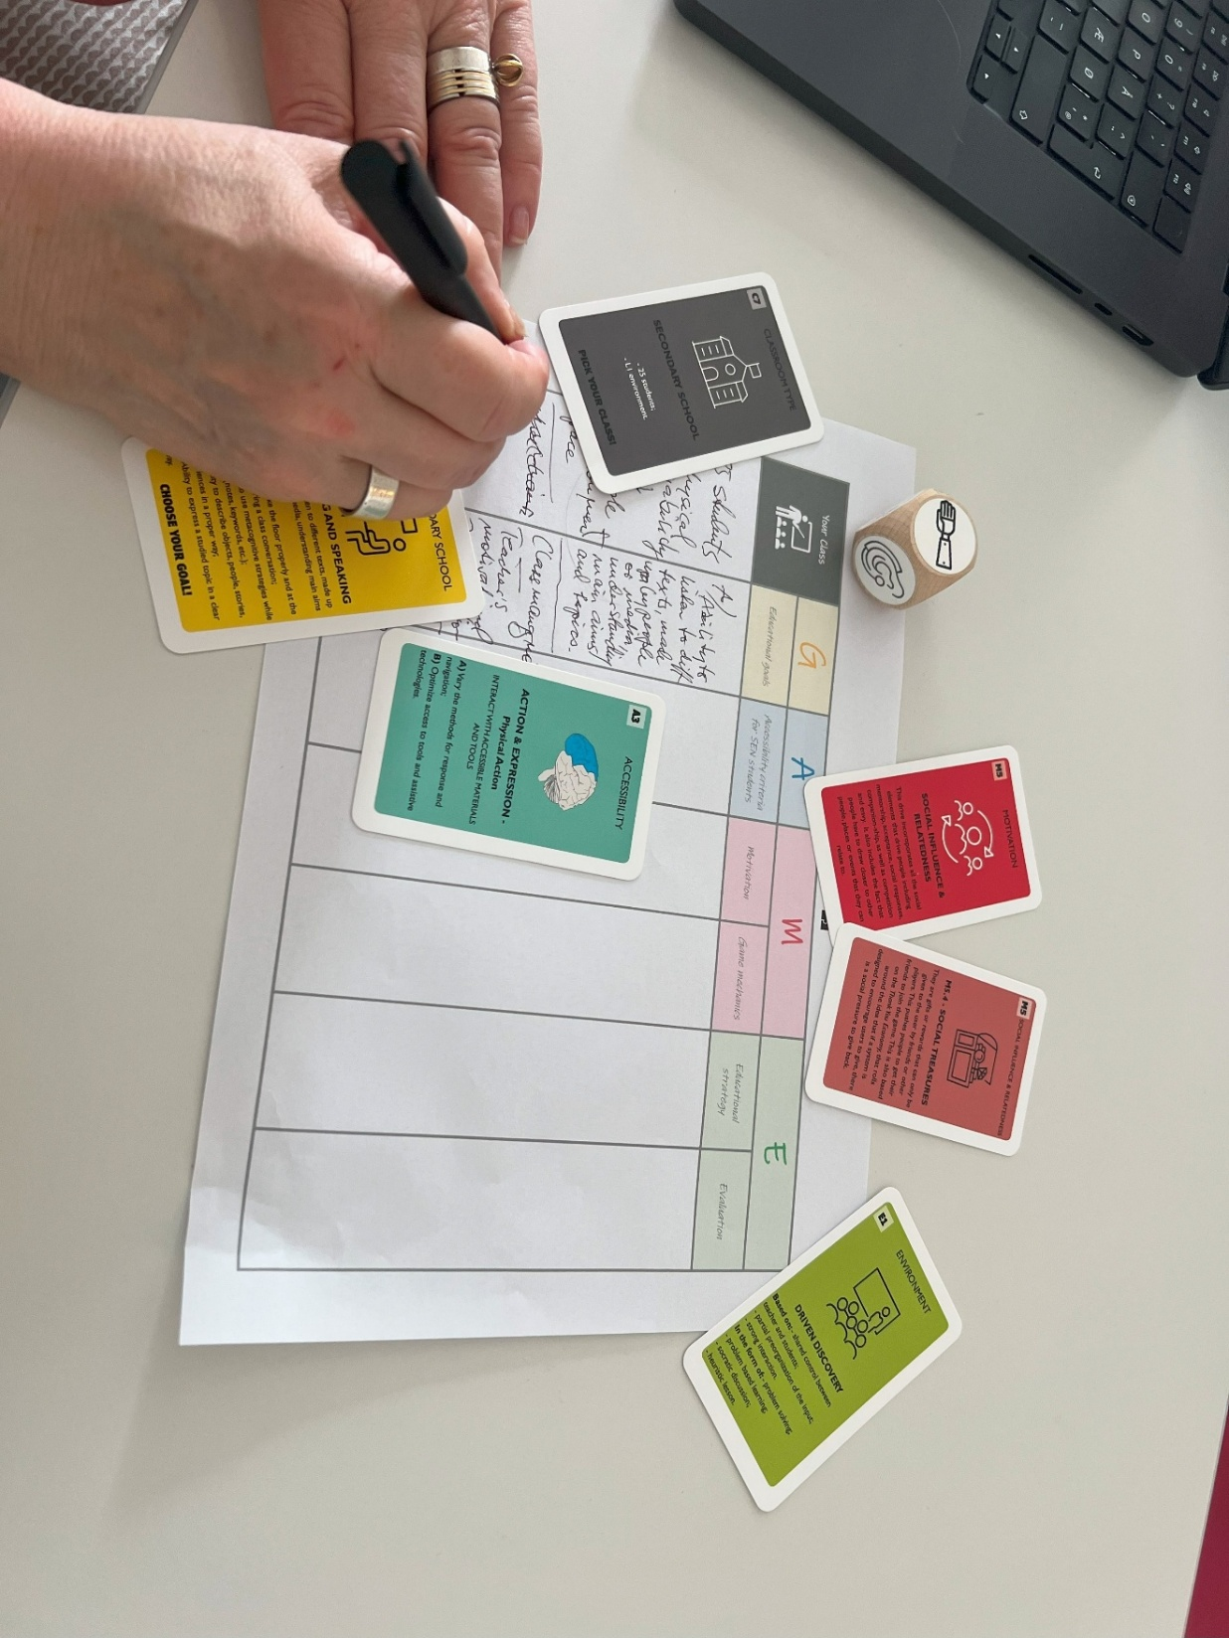

REPORT ON WORKSHOPS ON GAME METHODOLOGY
Marta Peracaula-Bosch

NAME OF THE METHOD | G.A.M.E
TRAINER | Marta Peracaula-Bosch
WHEN-WHERE | Leuven-31/5/2024
MICROTEACHING TOPIC | GAME is a tool aggregator that collects Learning design tools, Game design tools, Universal Design for Learning’s principles  Through the materials offered by the GAME model, teachers and educators can have at their disposal the main design elements related to inclusion and gamification
EDUCATION LEVEL | All levels: Kindergarten, Primary, Secondary, Higher Education (designers of learning experiences)
PREPARATION BY THE TRAINER | - Get training in the online sessions and face-to-face sessions about the methods  - Read carefully the synopsis of G.A.M.E in the Acadimia Synopsis document (pp 35-28)  - Read carefully the template of the G.A.M.E method in the Acadimia Joint Curriculum document (pp 26-29)  - Design how to summarize and see an example of the method in 0,5 hours  - Choose the materials that will be used. In this case where the cards, dices and design table.  - Print and cut the cards. Print as many design tables as groups there are going to be made with the participants.
SUGGESTIONS ON THE RESOURCES | The set of physical resources is very nice (cards, dices and design chart), although they are a bit difficult to locate. The link given in the synopsis https://playablecards.com/#scopri does not work. The cards can be found at the bottom of the page https://www.lte.unifi.it/vp-157-la-classe-oltre-le-mura.html  They should be upload in the “Resources” folder created for that purpose in the common drive (AKADIMIA\WP2- Design and Development of a Joint Creative Curriculum\T2.4 Resources\Game based learning - HI, UNIFI).  Some of the links to virtual resources do not work (Miro)
WHAT WE DID -APPLICATION | Steps:  - The method was briefly presented with a power point  - The participants in the micro-teaching were split in two groups of 3-4 people  - A GAME design table (available at the end of the cards document) was delivered to each group  - Each group was assigned a classroom age, learning goals, UDL principle to improve, method to improve motivation, environment and type of evaluation.  - By throwing the dice in the resources, each group get assigned some students with special needs.  - We shared the outcomes between the two groups
FEEDEBACK FROM TRAINEES | There was little time for the feedback but they commented the resources where very useful for an in deep analysis for a class and methodology design.
REFLECTION BY THE TRAINER AFTER THE WORKSHOP | In the microteaching only Phase 1 and Phase 2 of the 6 phases of the in-person sequence were conducted, for time reasons but these are the foundations of the method and give a good idea of it.
GENERAL CONCLUSIONS | The participants agree that the method can be of a great help for de design of learning activities that improve motivation and have in account DUA principles without losing sight of learning goals.
APPENDIX | Materials:  1. https://www.lte.unifi.it/upload/sub/file_pdf/ACA_Cards_G-A-M-E-_completed_11apr24.pdf  GAME instructions, cards, dices and design table  2. https://udlguidelines.cast.org  A framework to improve and optimize teaching and learning for all people  3. https://open-lab.com/4t/  Cards useful to find teaching strategies that can be used in an educational activity in a funnier and easier way  4. https://www.istruzione.it/inclusione-e-nuovo pei/decreto-interministeriale.html  Individualized Education Program (IEP) proposed by the Italian Ministry of Education
Any photos / videos? | Where they are, if any  https://drive.google.com/file/d/1enNXeqnjTu0BPAbugC__ay2_oKkWXDcq/view?usp=drive_link  https://drive.google.com/file/d/1SAWUdCevCuKU7BXZ1ERQrnbuFbMgR89t/view?usp=drive_link  https://drive.google.com/file/d/1Tfq7AeKdni-KwN-jTwrcu7si5oYLJwq4/view?usp=drive_link  https://drive.google.com/file/d/1C3MnT0VogpigxTM4MZipFAvVE3p5Dhu2/view?usp=drive_link  https://drive.google.com/file/d/1UMAk0MOQxc_ADgV827BipB0BBzxnzad_/view?usp=drive_link

