ACAδIMIA – Drama in Education
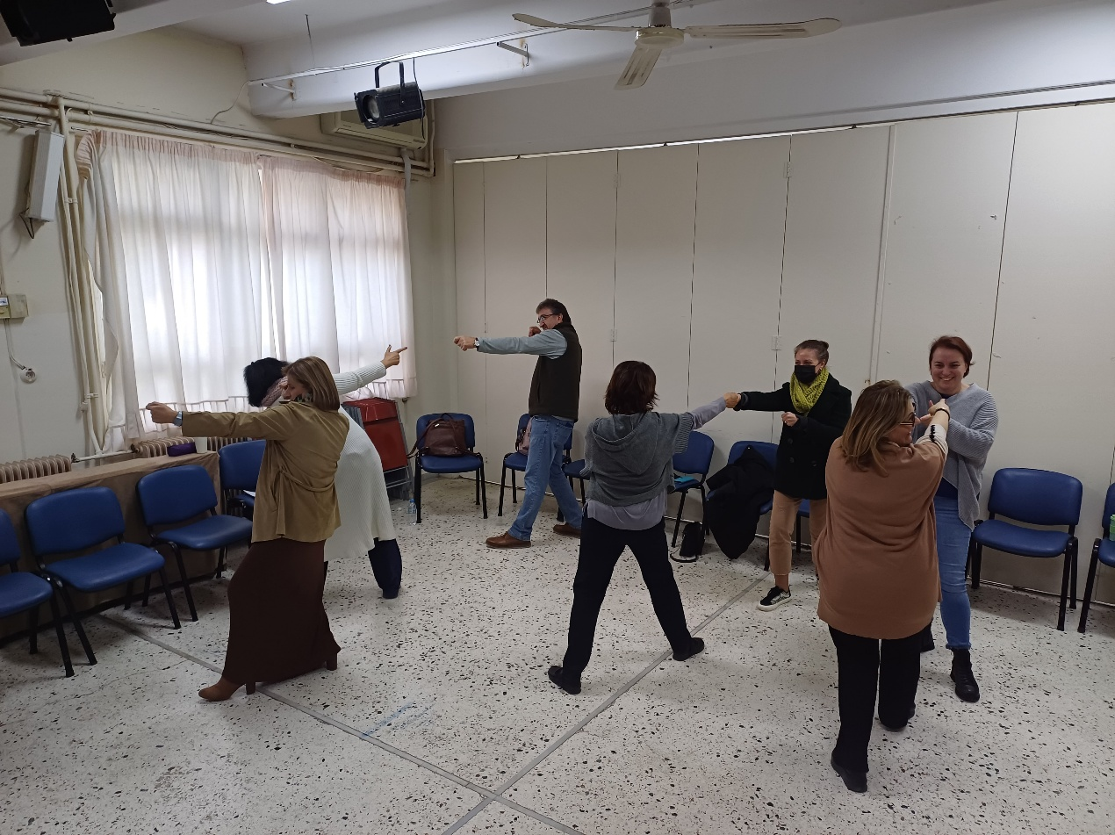
The third training session within the framework of the European program ACAδIMIA – «ACADIMIA-European Teachers’ Academy for Creative and Inclusive Learning» - was conducted using the creative learning method Drama in Education, which is based on theatrical techniques, for the teachers of the 2nd High School of Gerakas on Friday 24th of January 2025.
The teachers carried out the activities included in the Drama in Education with enthusiasm and creative imagination. The warm-up was done with the frozen frames, followed by the thought tracking. After setting the narrative context with King Minos, the Minotaur and the sacrifice of the Athenian youth, they created a poster with their thoughts as residents of Knossos. They played the "hot seat" activity with King Minos, they created a moving montage with two groups, where one was the choir and the other performed the dramatization of the young Athenians and finally, as youth of Knossos, they improvised when the king asked them to follow the procession of the Athenian youth who would be offered as a sacrifice to the Minotaur.
Afterwards, the teachers reflected on how they could integrate these techniques into their teaching subjects.

Responsible of Workshop

Pertsinidou Corinna
Coordinator of Educational Programs and Networks of the Directorate of Secondary Education of Eastern Attica
Trainer of ACADIMIA - «ACADIMIA-European Teachers’ Academy for Creative and Inclusive Learning»
