ACAδIMIA – Creative STEAM
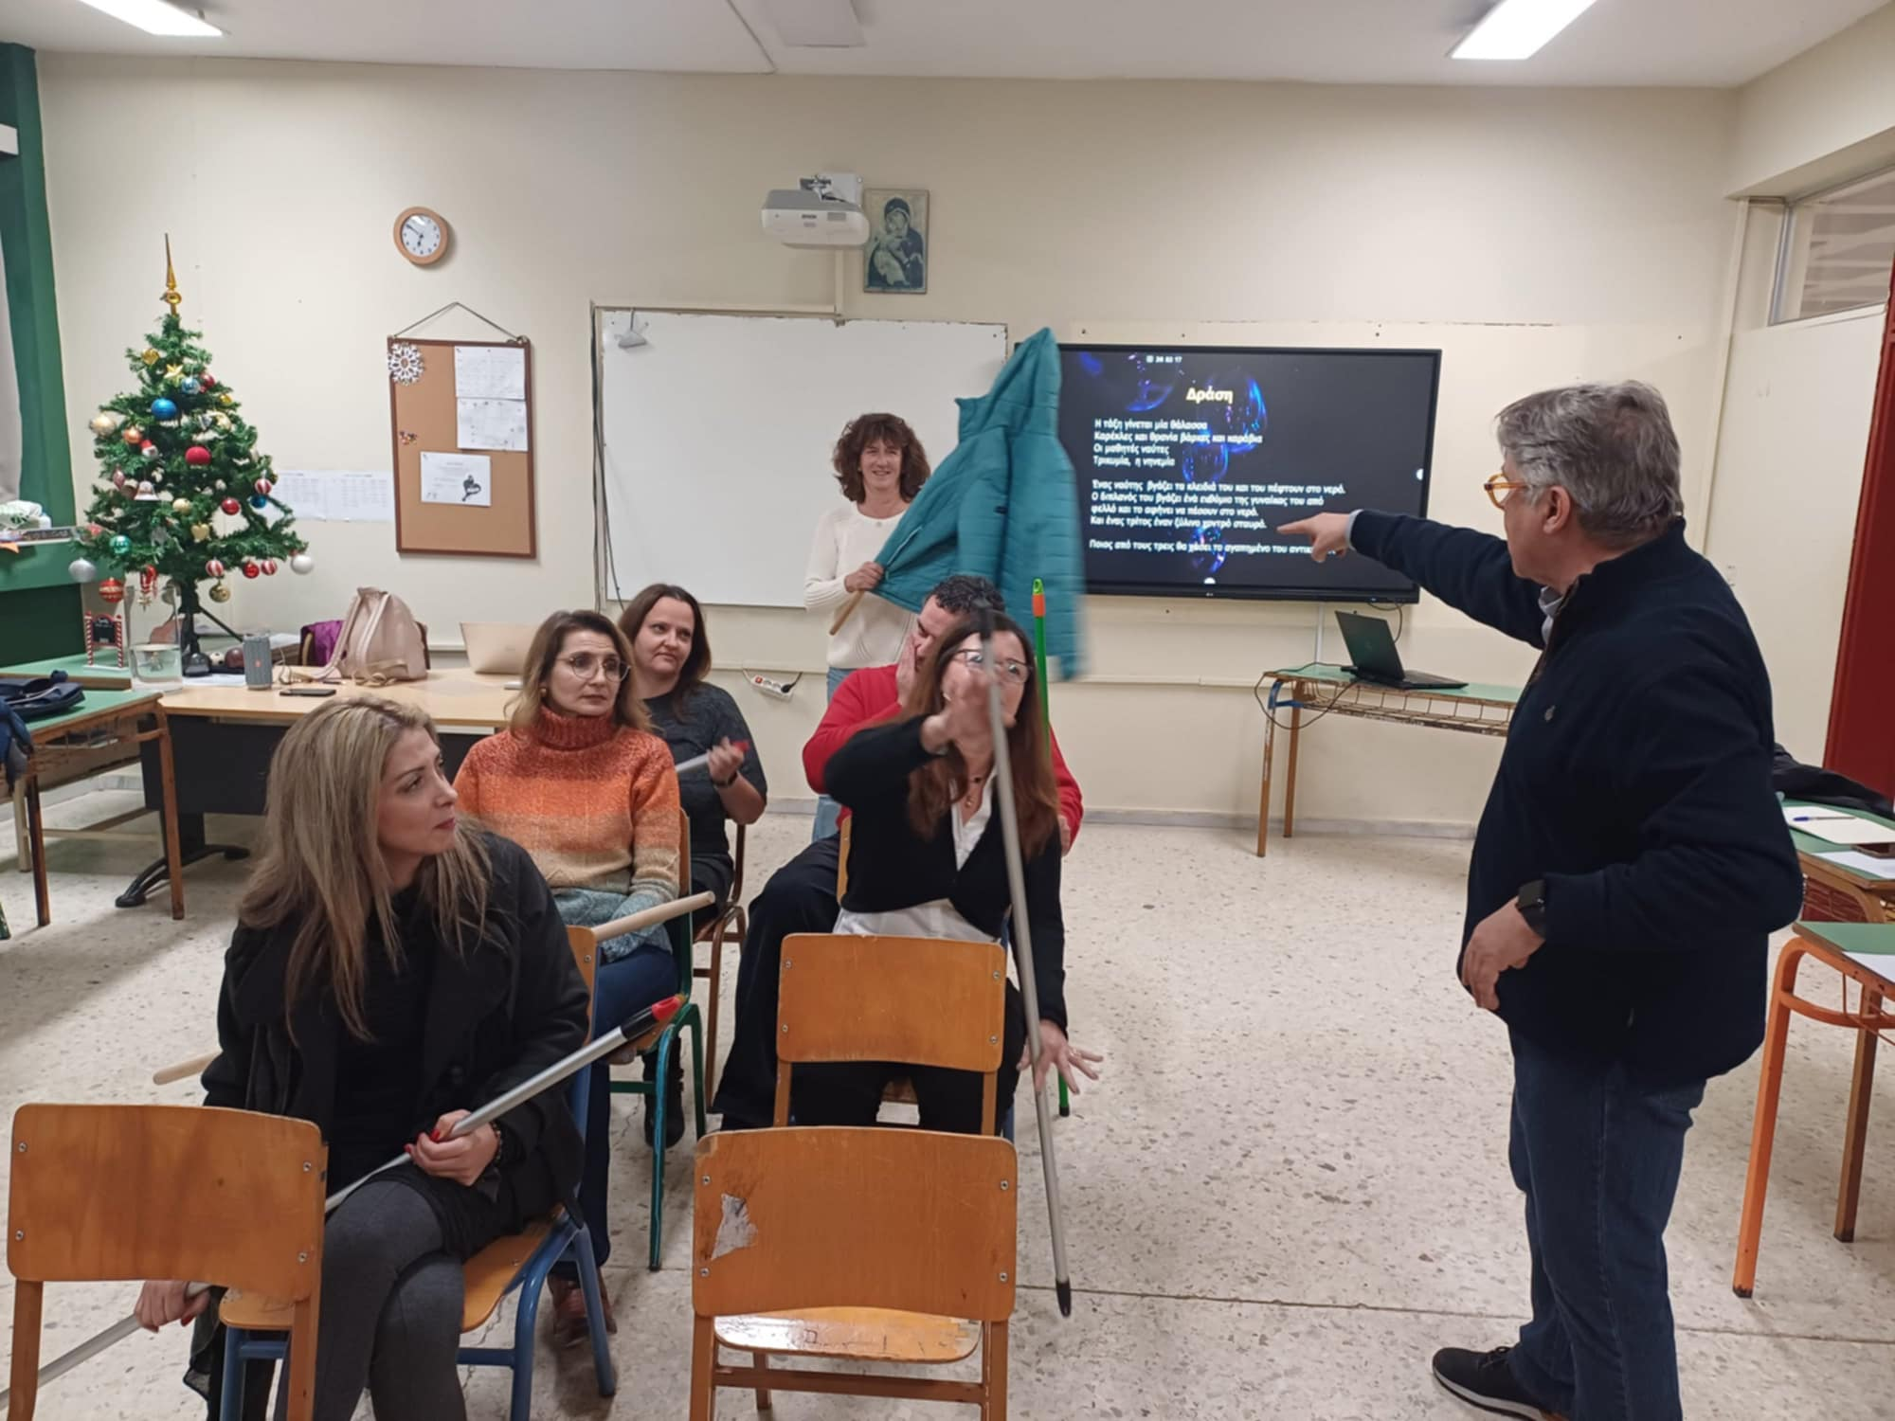

The first training meeting was held within the framework of the European program ACAδIMIA – «ACADIMIA-European Teachers’ Academy for Creative and Inclusive Learning» - with the theme of Creative STEAM to the teachers of the 1st High School of Gerakas on the 20th of December 2024.
After speaking about the benefits of Art in education, the theatre director Mr. Kamtsis, from the Centre of Higher Education in Theater Studies, held an experiential workshop on the topic of the rise of water on the occasion of Delacroix's painting "Christ at the Lake of Nazareth".
Then, Mrs. Pertsinidou, trainer of ACAδIMIA, presented the 11 educational lesson plans that were created and implemented in STEM lessons using the Creative STEAM method by teachers of the 2nd High School of Gerakas during the period of 2021-2023 in the framework of ERASMUS+ project. The participants left the meeting with many ideas for creating their own lesson plans.

Responsible of Workshop

Pertsinidou Corinna
Coordinator of Educational Programs and Networks of the Directorate of Secondary Education of Eastern Attica
Trainer of ACADIMIA - «ACADIMIA-European Teachers’ Academy for Creative and Inclusive Learning»

