Evaluation Development of Strengths (teacher) Name: ________________________ Class: __________ Date: ___________

Theme: ________________________________________________________






You felt : when you: _______________________________________

________________________________________
Happy Afraid Angry Sad Dislike Surprised

What we did: Goals of the lesson: You showed your strengths in: How did you learn:
Improvisation status  Writing: viewpoints  Writing: dialogues  Playing dialogues  Reflecting on assignments | - Students play high and low status in improvisations.  - Students vary with and between high and low status in improvisations.  - Students analyse high and low status and give each other feedback.  - Students experiment with creative writing using viewpoints.  - Students write dialogues using viewpoints  - Students write dialogues using status  - Students write dialogues using a combination of status and viewpoints. | O  O  O  O  Where you can improve:  O  O  O | 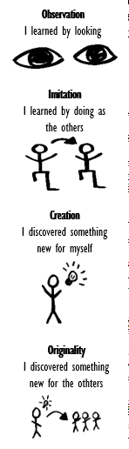

What did I learn? _________________________________________________________________________________________________

Your challenges: __________________________________________________________________________________________________

Where can you improve: ____________________________________________________________________________________________

What do I need? __________________________________________________________________________________________________

What is the next step? ______________________________________________________________________________________________

